## Configure Excel (QRC)

## Introduction

The Configure Excel QRC shows how to set up the optimal Excel configuration to utilize the EMAF Excel files on your ExxonMobil PC, and for managing and collaborating on artifacts located on the EMAF Architecture Repository.

## Configure Excel Instructions

### Create **My Templates** Folders

If Configure Visio QRC was not completed: From File Explorer, navigate to your network account **c:\users\<your network id>\LocalData** folder, and create a folder called **My Templates**

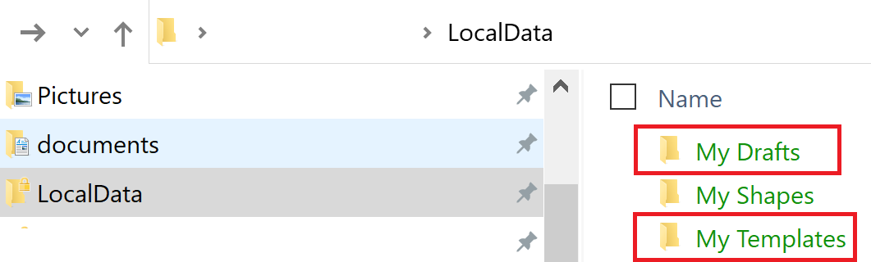

### To configure Excel to use **My Templates** Folders

1. In Excel, click the **File** Menu

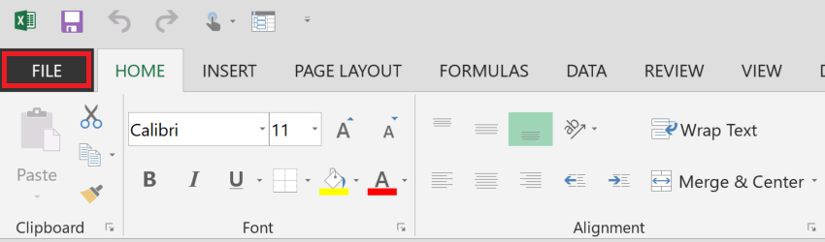

1. Click the **Options** Sub-menu

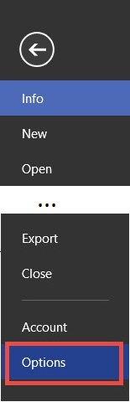

1. Once the Excel Option dialog box is displayed, click the **Save** option

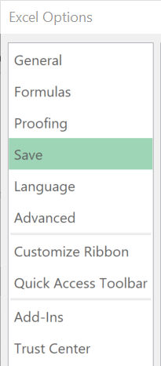

1. Configure the **Templates** Folders

* Click into the “Default personal templates location”, then set the path to your **localdata\My Templates** folder
* Click the **OK** button

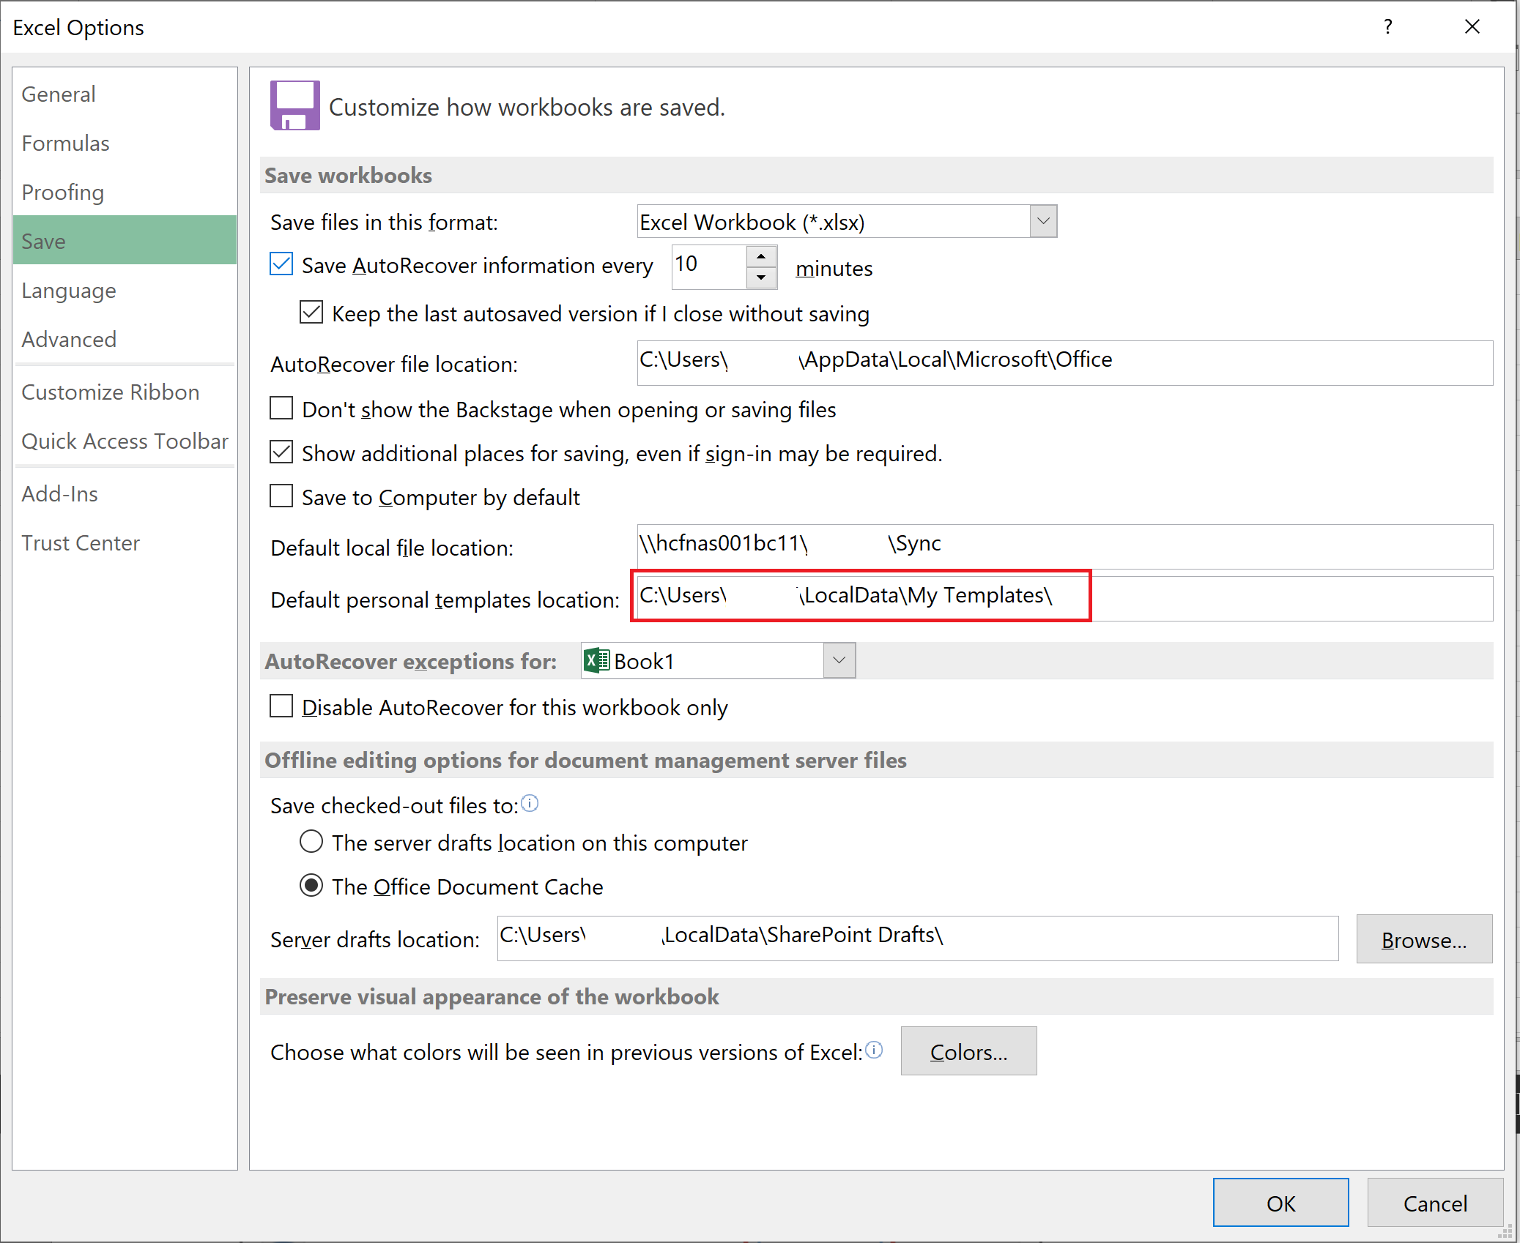

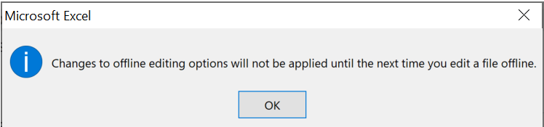

**NOTE: When you create a new artifact (File -> New -> Personal), all EMAF templates will be displayed**

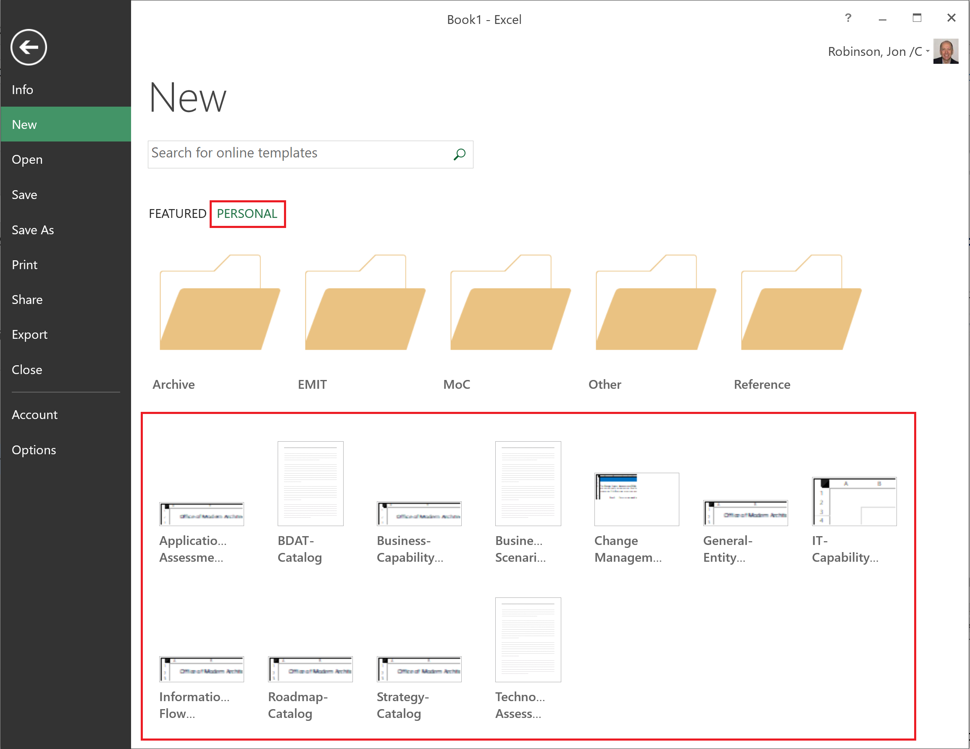

### To pin EMAF Architecture Repository Targets

Once you have begun opening or saving Excel workbooks to folders in the EMAF Architecture Repository, these folders will begin to appear under your Recent Folders area which you can then pin these locations for a quick and convenient way to access these locations in the future.

1. In Excel, click the **File** Menu



1. Click either the **Open** or **Save As** Sub-menu, click **SharePoint** or **Other Web Locations**, then under the **Recent Folder** area select the SharePoint location and click the **Browse** button

NOTE: The SharePoint option will be enabled once you start working with artifacts on SharePoint.

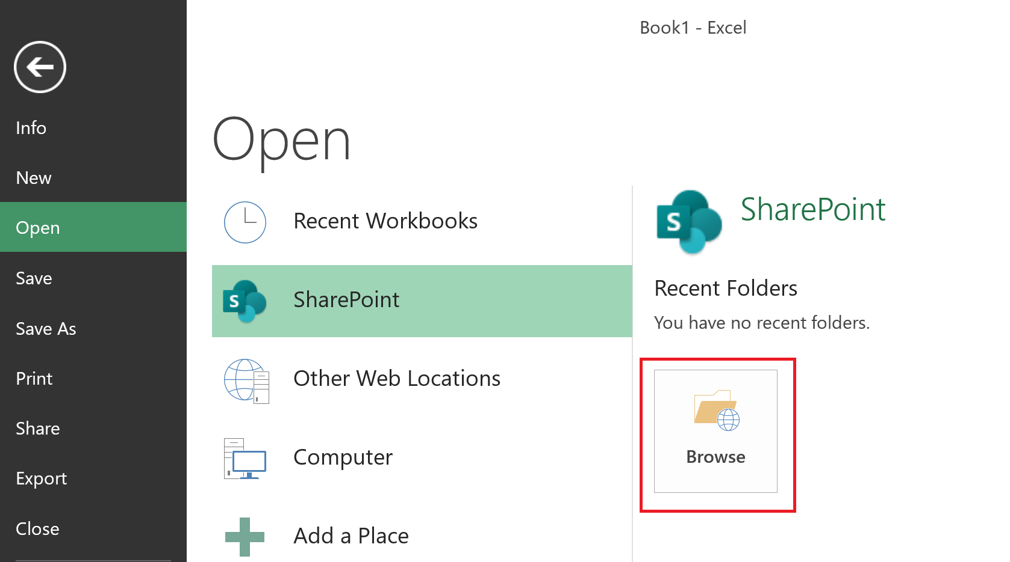

1. Within the Open dialog box

* Copy/paste the following URL into path field: <https://ishareteam4.na.xom.com/sites/Architect/Architecture%20Repository>
* Select the following file: **Use-For-Setting-Up-Excel.xlsx**
* Click the **OK** button

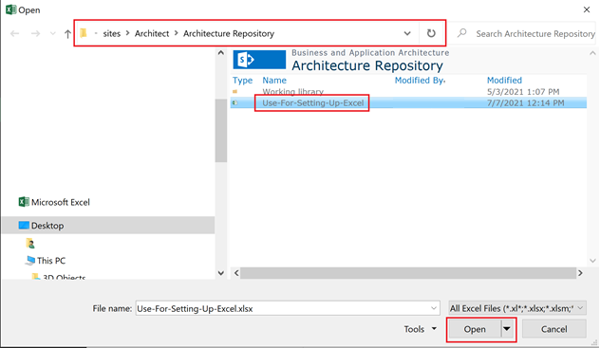

1. Now that the goto/ArchRepo path has been registered within your Excel client, perform the following steps

* Navigate to **File -> Open -> SharePoint -> Recent Folders**
* Right mouse click on the **Architecture Repository** entry
* Select **Pin to List** option

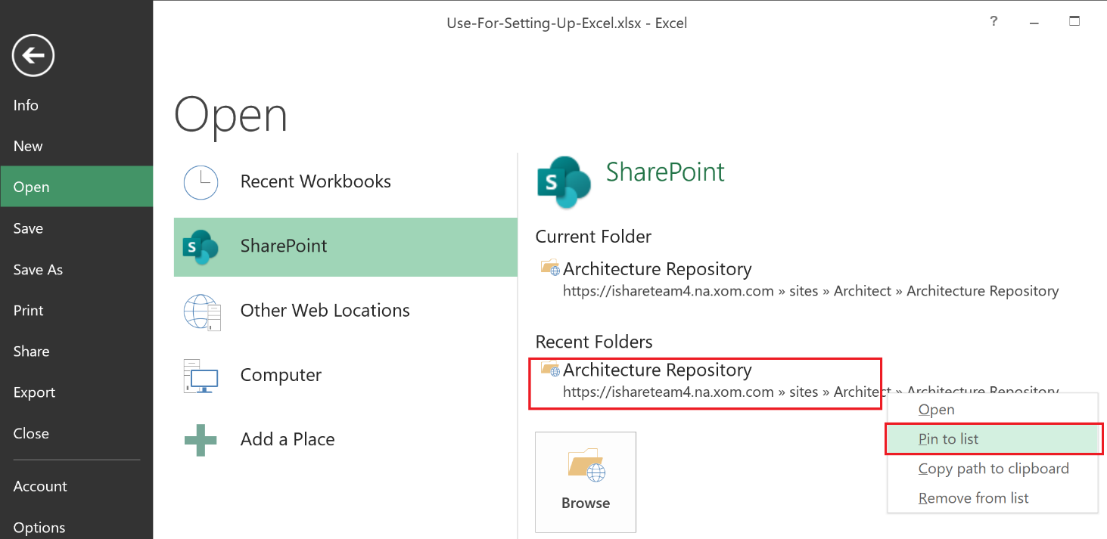

1. To use the pinned locations, simply

* Navigate to **File -> Open -> SharePoint** or **File -> Save As SharePoint**
* Click the pinned location you want to use
* Click the Browse Button

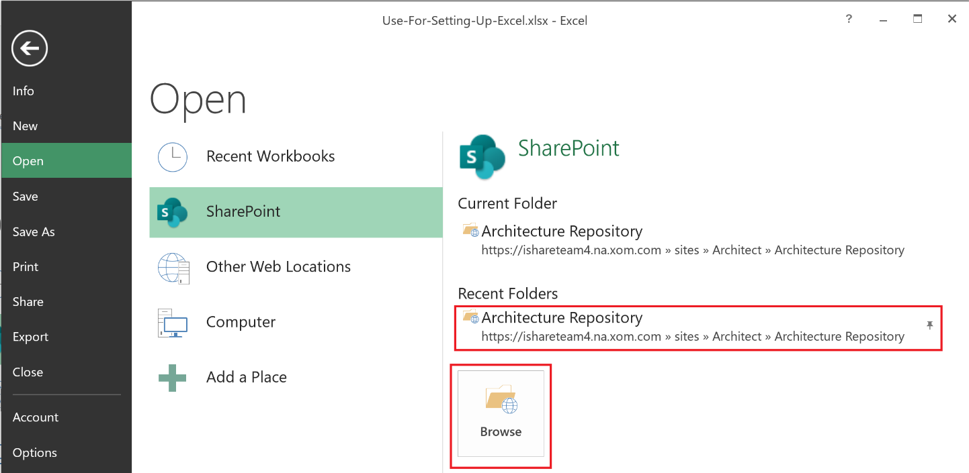

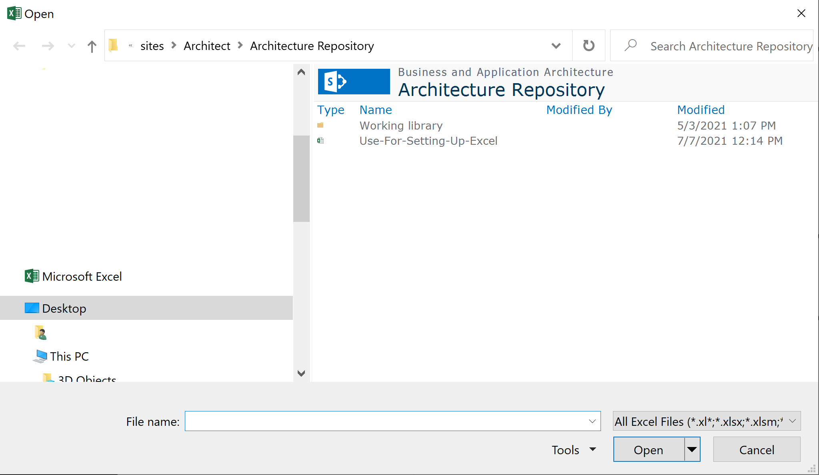

**NOTES:**

* + **These steps also work for Other Web Locations within the Excel Open dialog.**
  + **Repeat steps 1-6 for your project / architecture repositories located under Working Library.**